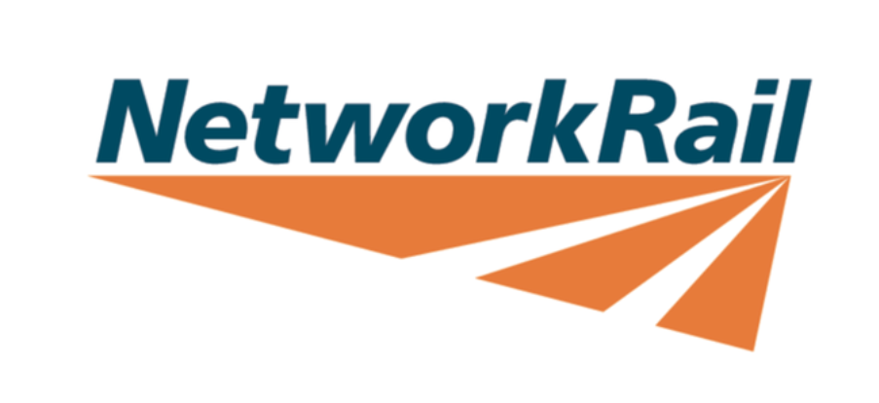Trace Review App
  - Guide on functionality and how to use the app

Created and Maintained by Brogan McGuire
Table of Contents
Overview 3
Purpose 3
Methodology 3
Current Limitations 3
Next Steps 3
Guide 4
How to download the app 4
How to install the app 4
How to start the app 4
How to get the data 4
ASCIIDataPump Export 4
CDDS Export (Currently unstable) 4
How to import the data 4
How to use the app 4
How to review the trace 4
How to export to trace 4

Overview

Purpose

Methodology

Current Limitations
As this app was developed to be used by the tech team at Doncaster there are some functions which are currently available to Doncaster’s patch, but these can be made available to the wide depots if they decide to adopt this process. Some of these functions that are limited to Doncaster are the following: OTM Plan, Structures and S&C.
There are 2 versions of this app one that runs locally on your machine with full app functionality and one that runs on the web but doesn’t have the CDDS search or export to pdf functionality. The web version is intended to be used as a demonstration for the full application without having to install the application on your local machine.
Currently there is 2 ways to get the required geometry data you will need to conduct the trace review. The first way is to use the ASCIIDataPump excel file which extracts the geometry data slowly but does not have any formatting issues on the data when complete. The next way is the use the CDDS search function within the application, this is a faster export however it has some formatting errors in the data which causes anomalous values in the trace so I could not recommend using this data for your trace review. I am currently trying to find a fix for this function, however I have yet to find a fix for it.

Next Steps

Guide

How to download the app
- Open this file location Doncaster Technical Hub - ATME FOLDER - Trace Review app files - All Documents
- Download the “Trace Review App.zip” file
- Extract the file to where you wish to save it

How to install the app
Before using the app for the first time you need to install the node modules.
- Connect to 102 WiFi
- Double-click `start.bat` — it will detect that `node_modules` is missing and run `npm install` automatically
- When prompted, confirm you are on 102 WiFi and press any key to continue
- Once installation is complete, switch back to Ethernet or 14 WiFi when prompted, then press any key
- The server will start and your browser will open automatically
You only need to do this once. After the first run, `start.bat` will start the server directly without installing anything.

How to start the app
You can start the app in two ways:

Option 1 - Double-click start.bat (easiest)
- Make sure you are connected to Ethernet or 14 WiFi
- Double-click `start.bat` in the app folder
- A terminal window will open and the server will start
- Your browser will open automatically at http://localhost:3000
- To stop the app, close the terminal window or press `Ctrl+C`

Option 2 - Manually via Command Prompt
- Make sure you are connected to Ethernet or 14 WiFi
- Open Command Prompt (press `Win + R`, type `cmd`, press Enter)
- Navigate to the app folder (adjust path if needed): cd /d "C:\Users\BMcGuir\OneDrive - Network Rail\Profile\Desktop\Trace Review App 3.0"
- Add the portable Node.js to the path for this session:set PATH=%CD%\node;%CD%\node\node_modules\.bin;%PATH%
- Start the server: npm run dev
- Open your browser and go to: http://localhost:3000
- To stop the server, press `Ctrl+C` in the terminal window

How to open the app
- Open browser
- Visit http://localhost:3000

How to get the data
First you will have to find the data of the latest trace for the section of track which you are wanting to review. There may be newer dates in the search but these traces have not been validated yet so avoid using them

ASCIIDataPump Export need one that works
- Download the ASCIIDataPump from Doncaster Technical Hub - ATME FOLDER - Trace Review app files - All Documents
- Open the excel file in desktop and enable macros
- Select ELR, TrackID, starting eight and finish eight (tip for making small movements in the ELR column, click on an ELR then left click and hold as you move the mouse up or down as needed to get to the required ELR.)
- Click get dates and select the date you found previously
- Click browse and select the location where you want to save the file
- Add this to the end of the file path and update to suit your extract. “\Date ELR TrackID Startmileage to Endmileage.csv” for example “\260413 ECM1 1100 156 to 175.csv”
- Wait for the data to export. This might take a while

CDDS Export (Currently unstable)
- Open the Trace Geometry Engine App
- Click Search in the top left
- Enter your required ELR, TrackID, Start and End Mileage
- Click Find Available Date and select the date you found previously
- Wait for data to import into the app, this will take a minute to do. This data isn’t 100% accurate so the previous method should be used.

Track Geometry Reporting data

How to import the data

How to use the app

How to review the trace

How to export to trace

